SIT 120

Week 01

In this week we learned about html, CSS and Java-script. We looked up references from W3Schools website and created my first web page, the web page contained 2 headings, 2 paragraphs, a table, a picture, a list downwards, a button and CSS was used to style the page, changing the background color and the color of the headings. The java script file contained variables called by id’s and class name which were used to change the text of both the headings and other functions of those id’s. Learned about Vue js and to create a component to make a todo list.

.html and .css

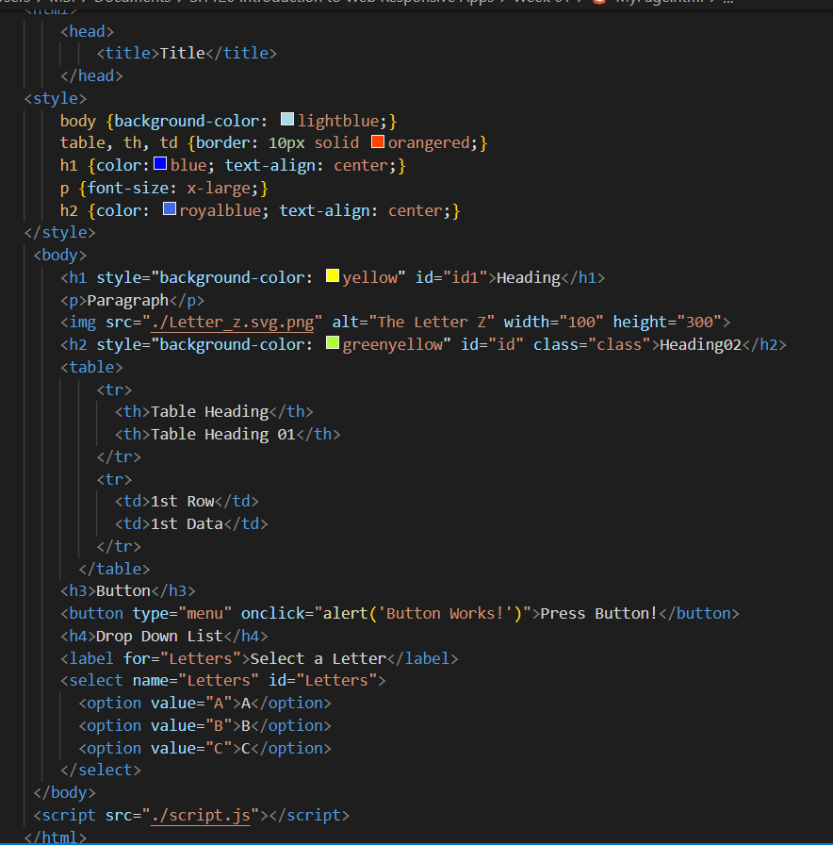

Week 02

Task 1:

A responsive web design is way to order for a web page to change it’s width and height according to the screen size, this is important since when opening the web page will cause problems and it will not be displayed properly. When creating a web page responsiveness is one of the main fundamentals since it gives the user the design of the web page in an attractive pattern no matter the screen they are viewing it through.

.html

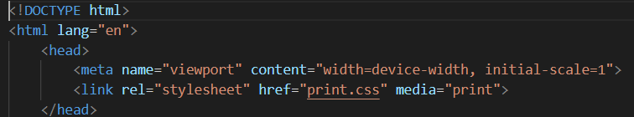

Task 2:

CSS can be used to change the layout of the page like the size of the words on the page by adjusting the pixels to fit a screen size and the way it is displayed by dividing the page into formats like Grid or Flexbox or Multiple-column layout. Then @media was used in order to adjust the screen width of the web page according to the device by adding break points when a certain pixel width is exceeded.

.css

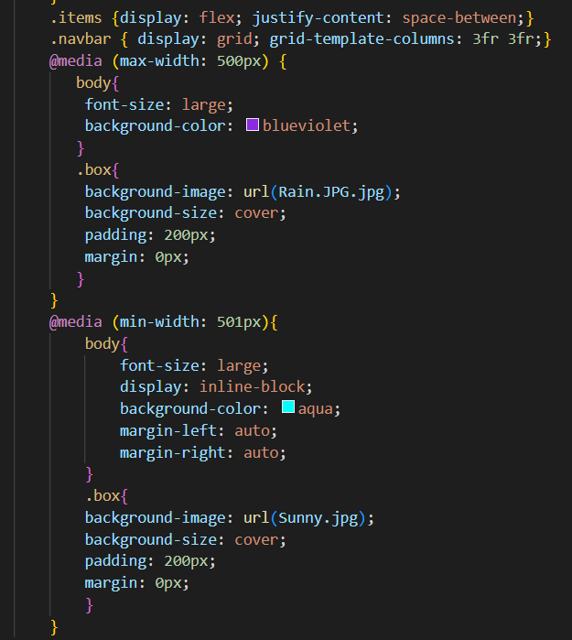

Task 3:

User Story 1: As a user I want to make sure to mark all my products that I buy regularly.

Criteria: There’s a marking option on the item which will allow the user to make their product be easily accessed.

User Story 2: As a user I want to be able to buy more than one quantity from a product.

Criteria: There will be an option to select the quantity needed to purchase from the certain product.

Figma Diagram from a figma prototype

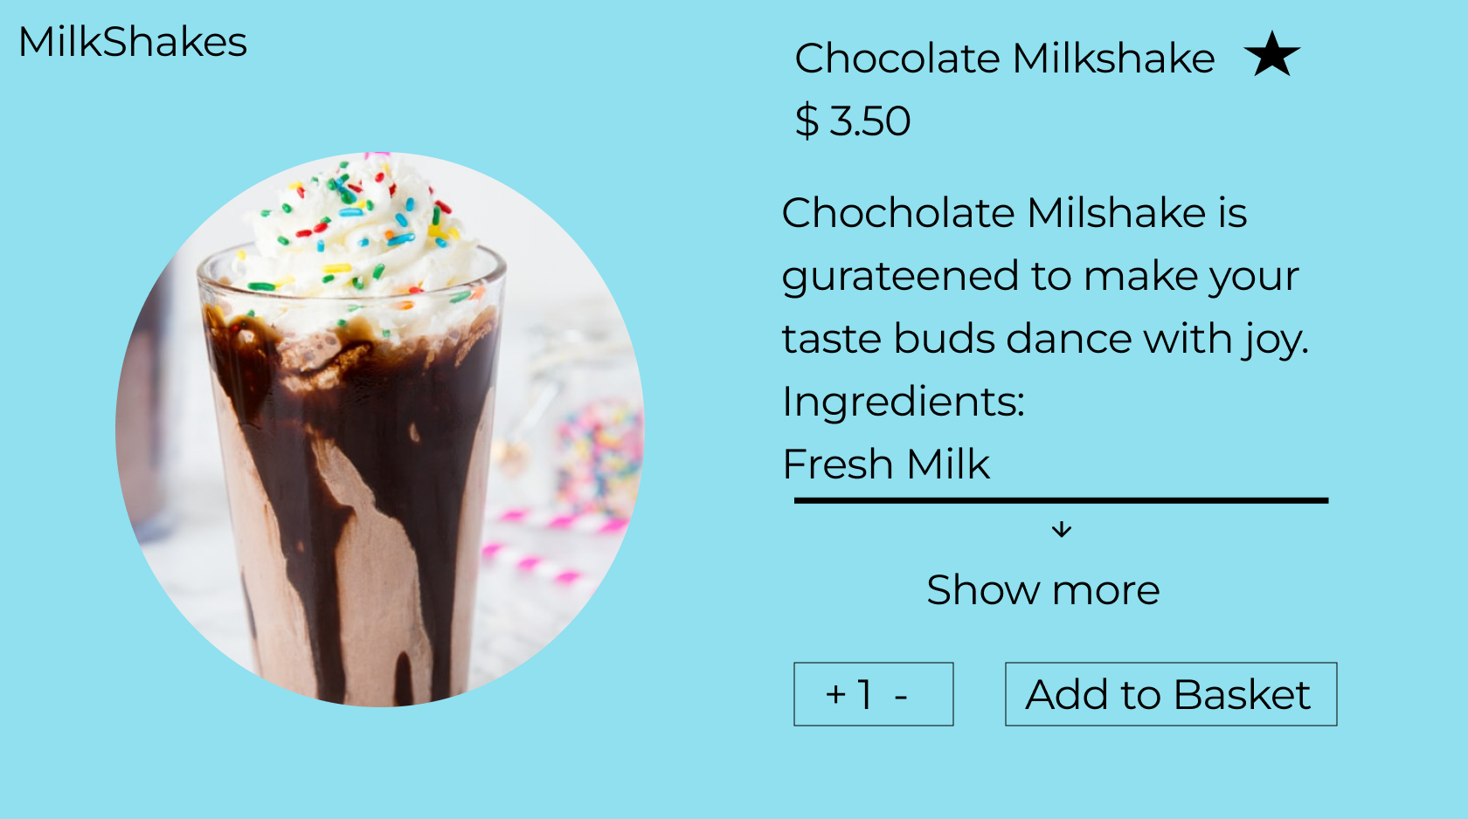

User stories and figma diagrams are really important when creating a website since it provides a clear diagram and functions the website should achieve before actually creating it.

Task 04:

These can be used in a webpage to add more functionality and can be used by the user to interact with the web page. These functionalities include adding a canvas, where a picture of something can be drawn using the code, a video tag to display a video to the user, an audio tag to give the user something to listen to, and an embedded youtube video which displays the controls of youtube along with the video. In all these functions there are attributes that can be changed like give the video or audio to loop or display controls by adding a few lines of code.

.html and .js

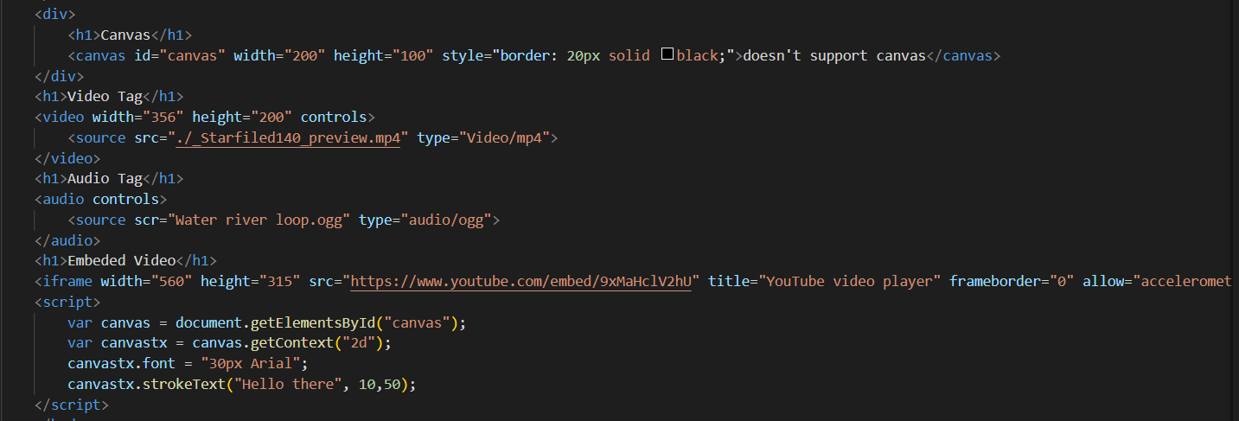

Week 03:

Task 1:

This task incudes using string methods to alter strings in javascript, first the length can be found using the length method then texts can be replaced, texts can be changed to uppercase or lowercase, two strings can be connected using concat, slice can be used to cut a section of a sentence by giving a number.

.html and .js

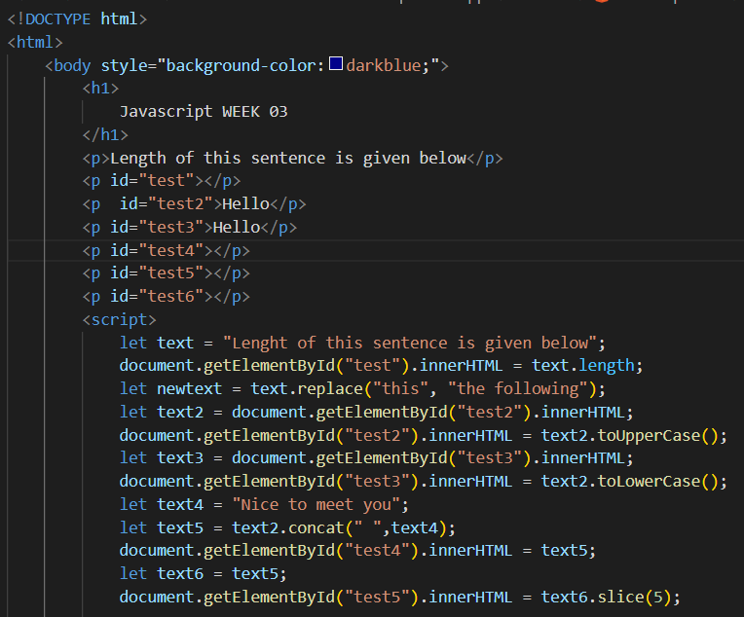

Task 2:

This task uses numbers and arrays in javascript. The first was string array named food is made then the amount of strings in the array can be given by length, then push can be used to input a new string to the array, find can be used to use a function to get a specific string. Then secondly a number array was made named number1 and number2 which is combined by using concat, pop was used to remove the last number of the number1 array.

.js

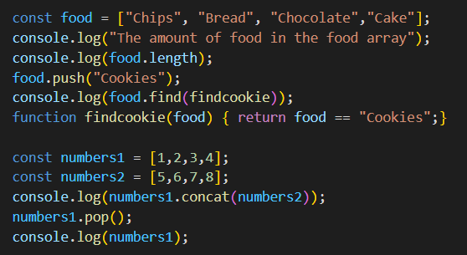

Task 3:

These methods helps us to display the time in different formats and set the time to different times by changing the day, month, year or even the hour, minute, second and milli second. These dates are used by javascript and uses console log to display them. The date functions are helpful since when designing a website you can add a separate function to display the time and set it to change according to the relevant time zone using these methods.

.js

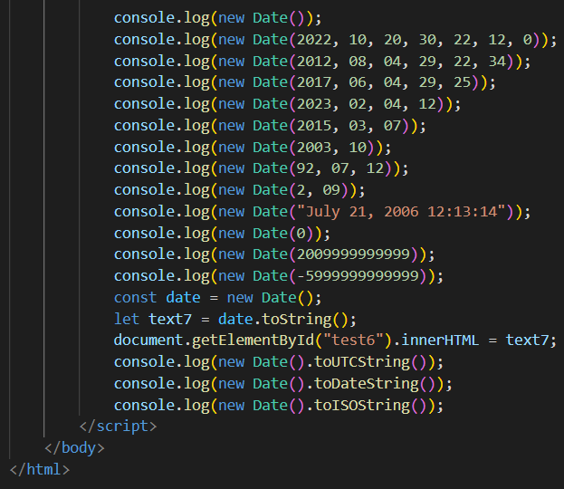

Week04

Task 1:

In this task we build our very first vue application, which is a framework to Javascript, we use this vue app to display a text on the screen called hello world. Vue app contains the text inside it in the javascript and it is called by a div which as an id app, that displays the text.

.js

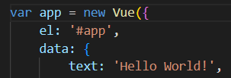

.html

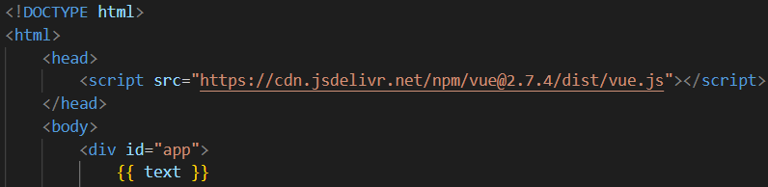

Task 2:

These conditionals can be used in vue to change the data according to a statement by using v-if and v-else and v-show can be used to display data if a statement is satisfied, and v-for can be used to display a set of data in an array.

.js

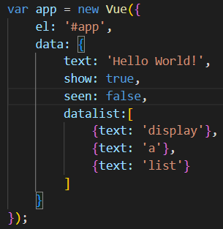

.html

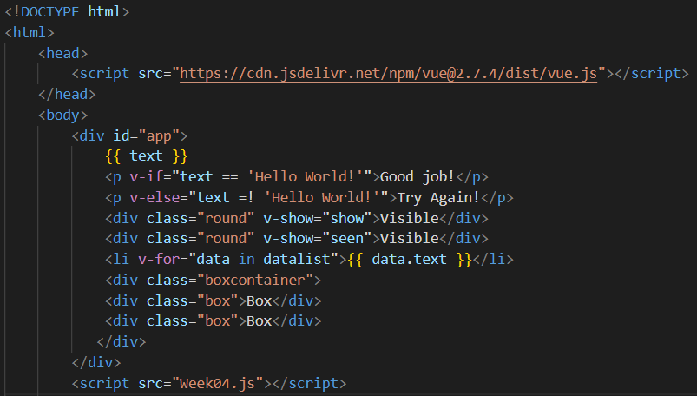

Task 3:

Responsiveness in vue using flexbox allows the webpage to fit into any device it is supposed to fit, and it will not require any user interaction since it resizes itself. This feature is really helpful when implementing responsiveness in a web page since it changes to fit the relevant screen size the user is currently accessing the webpage in.

.css

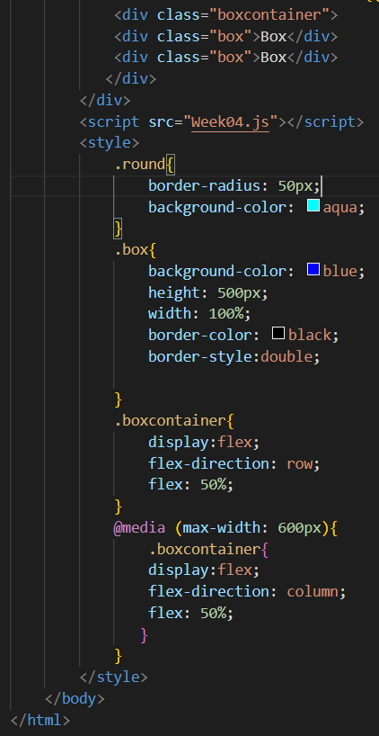

Week05

Task 1:

Components in vue can be used to avoid code duplication, so this provides code reusability. Components can be registered and there are 2 types of components which are local and gobal, local can only be used within that assigned specific component and global component can be used anywhere including in other components. Local registration of components are mainly used since using global registration is not ideal because if it’s not wanted anymore it will still occupy a portion of the final product.

Task 2:

V-model can be used to bind an input form to get information from a user, so this creates interaction with the user. There are multiple forms of V-model and it is different for each one like for check box, checked property and change event is used to bind, for radio buttons also uses checked property and change events.

Task 3:

Props can be used to pass data or information from a parent component to a child component, it’s a one-way path if the parent is changed then the child component will also be changed but if the child component is changed nothing will happen to the parent component.

Custom events are used to be emitted or listened to by components by using a emit method and v-on method. When emitting arguments can be placed to check if the data fit to the category and emitted event can be registered on a component, events can also be checked by this.emit which gives a Boolean to tell if it’s correct or not, V- model can also be used to bind an events and can also be used by using a get and set method.

Slots can be used to give out certain parts of information or data by using slot keyword, when a component reads slot it is replaced by a template given by the slot syntax.

Week 06:

Task 1:

In this task we used vue to create an input type password and text for passwords and email respectively, by using v-model to bind the input to a data which is set to return the input to be displayed below the input box in a p tag. This is really good example of using v-model as discussed in the previous week the data in given in and is been given out in the paragraph tag.

.js

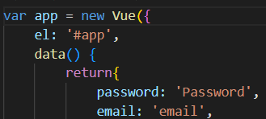

.html

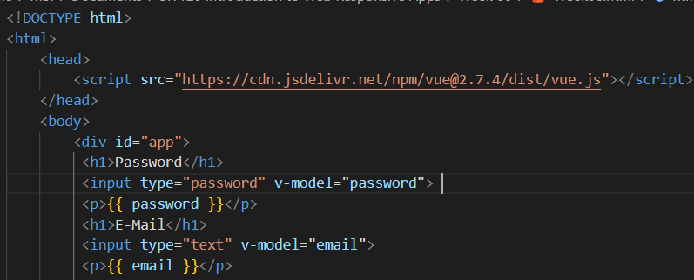

Task 2:

Checkboxes are used in vue to return a data that it has been, bind to using v-model and using a label to display each checkbox text, this can be used for selection from a data given in the form of checkboxes. This task also uses v-model like the previous week to implement the checkbox function, where it displays the selected one.

.html

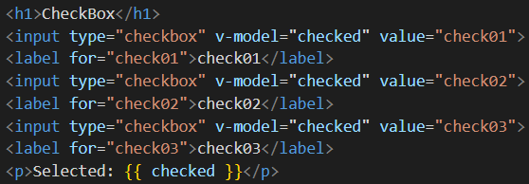

.js

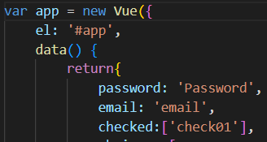

Task 3:

This is used in vue to create a multiple options feature, to show the one that is chosen by the user. Using v-for and v-bind each data is attached to their id’s so when it’s chosen it will be displayed below. This is not like the previous example this is entirely on data written with an id which is being called.

.html

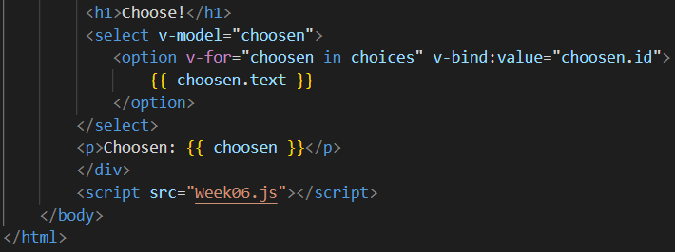

.js

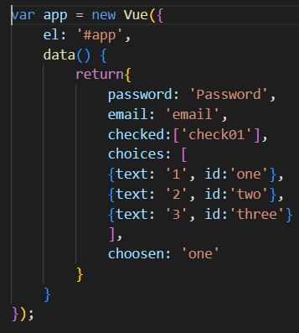

Week07:

Task 1

This task focuses on components that we did research on week5 task 1, which enables us to create a two components locally registered and globally registered, which registered locally means only that specific component can be used in one instance that has to be called inside it whereas globally registered components can be called in a component can be called in any vue instance. Local registered components are ideal for single templates that it is only used in one instance and globally components can be used when it is used in many components.

.js

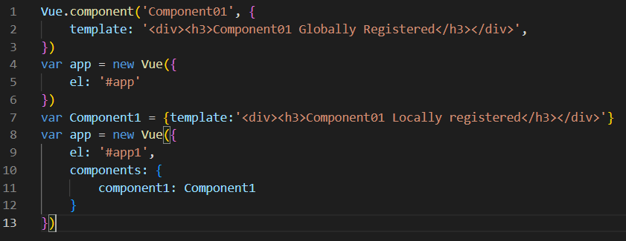

Task 2:

Props as we have learned before in Week 5 task 3, props can be used to pass data from a parent component to a child component, in this task we learned how to implement such a prop. First create a component then to the component add a field called props and enter a name for the prop, then the template with the name of the prop within curly brackets, after called the app in div in the html and type the name of the component along with the prop name and the message to be displayed as shown below in the screenshots.

.js

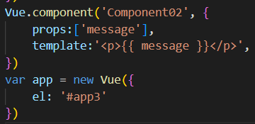

.html



Task 3:

Customs events are set in place to pass data from the child component to the parent component like discussed before in week 5 task 3, where are description of custom events is given. It is implemented by using a emit method to send the parent component from the child component then the parent component sends that to the relevant method it is connected to.

.js

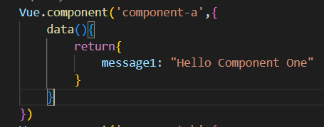

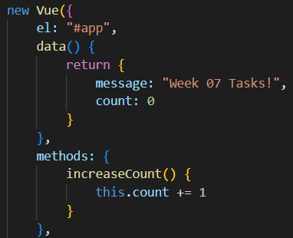

.html

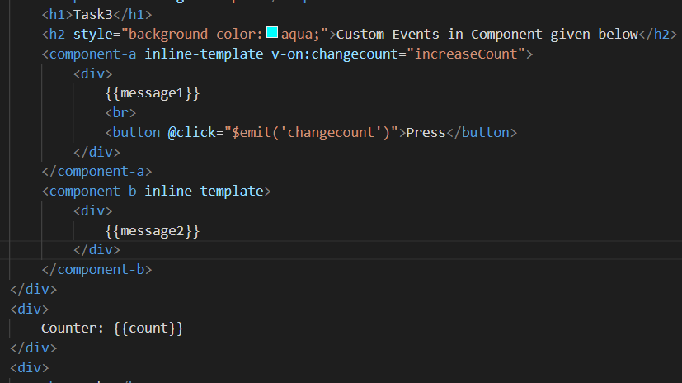

Task 4:

Slots is another way to parent component to the child component like props discussed in week 05 task 3, and the data can be added using the keyword <slot>, the data is written in the parent component and it is displayed in the child component through the keyword, they can also be assigned with a name using sloth=”name” that can be used to get that specific slot.

.js

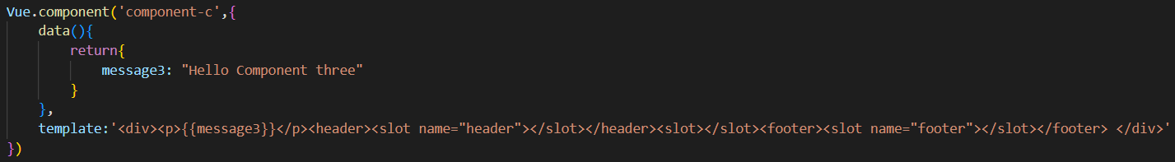

.html

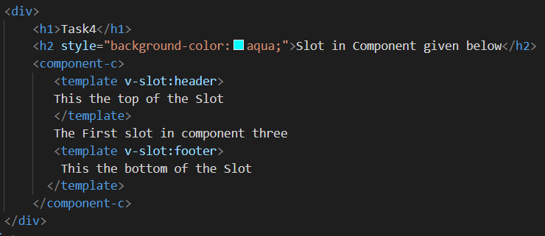

Project Progress:

Week 3 and Week 4

These two weeks were used up in learning about html, css and javascript, where and how I can implement it in my project. I used my intial submission the proof of concept and made it better by styling it using css made the home page more responsive. Then using figma I created a login page and a product page for the design as shown in the project proposal. Then in week 4 learning about vue, I implemented different components in the home page like navbar.vue and footer.vue which I was going to use again for my other websites.

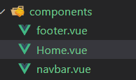

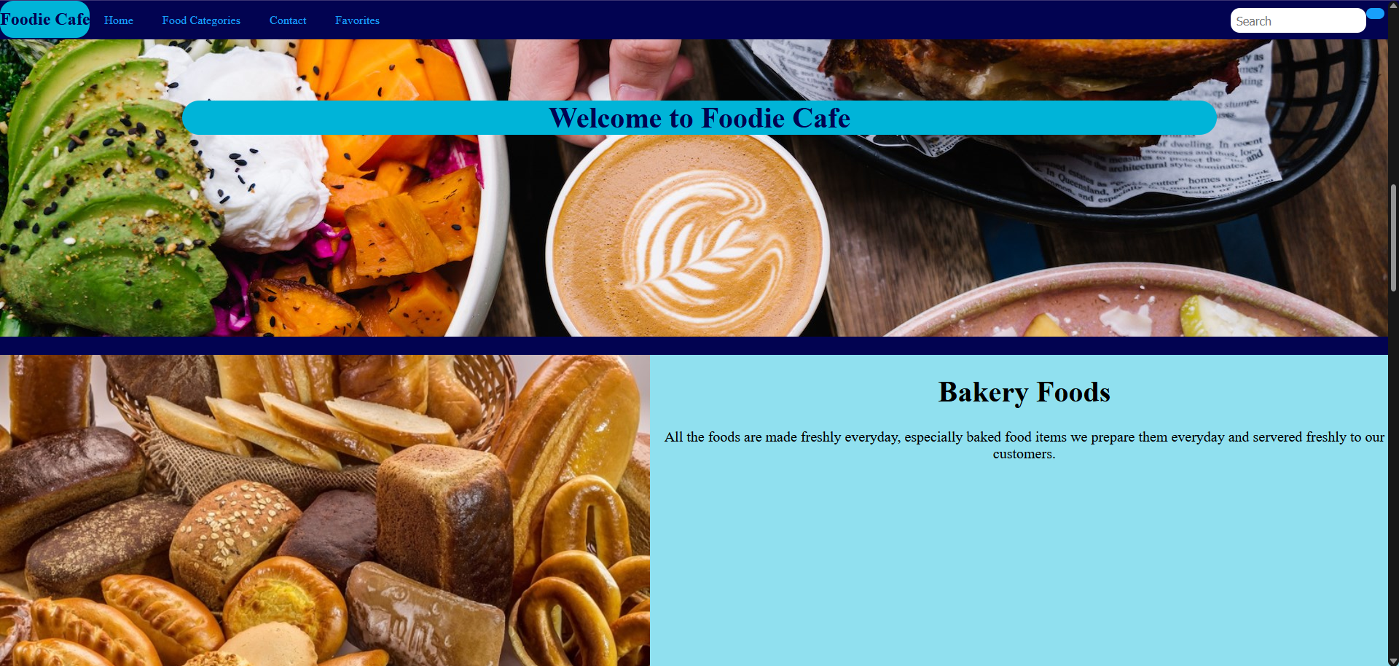

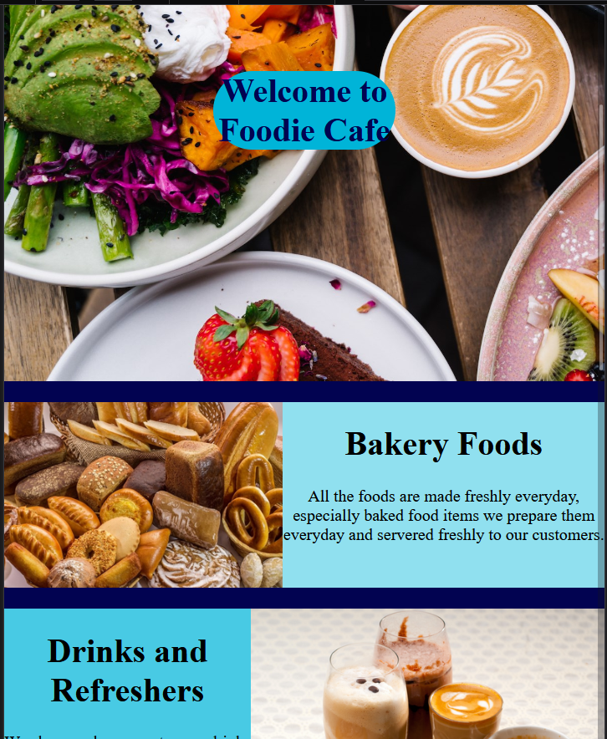

Week 5 and Week 6

In the following weeks I created an image slider component to pass slides after a time duration with a transition animation by using vue, onclick for the slide buttons to move them to the previous slide or the next slide, used css for the transition animation and used methods to implement the functions of slide change and the transition duration. Then I started on creating a product page for milkshakes I created a vue component for the product and added the navbar and footer to the product page component. Then I added a comments section to leave comments on the specific food item using v-model and emit to send data from the product review component to the product component and added a prevent method to display errors if a field is left empty.

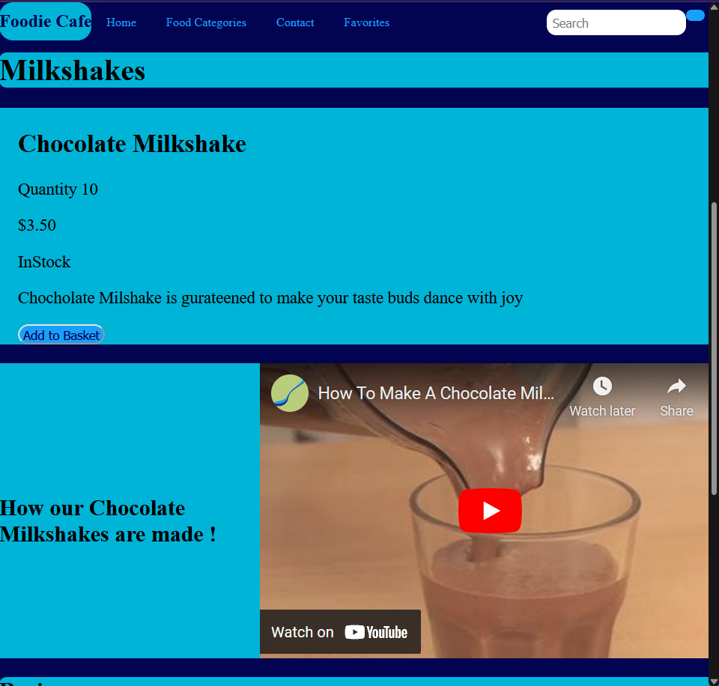

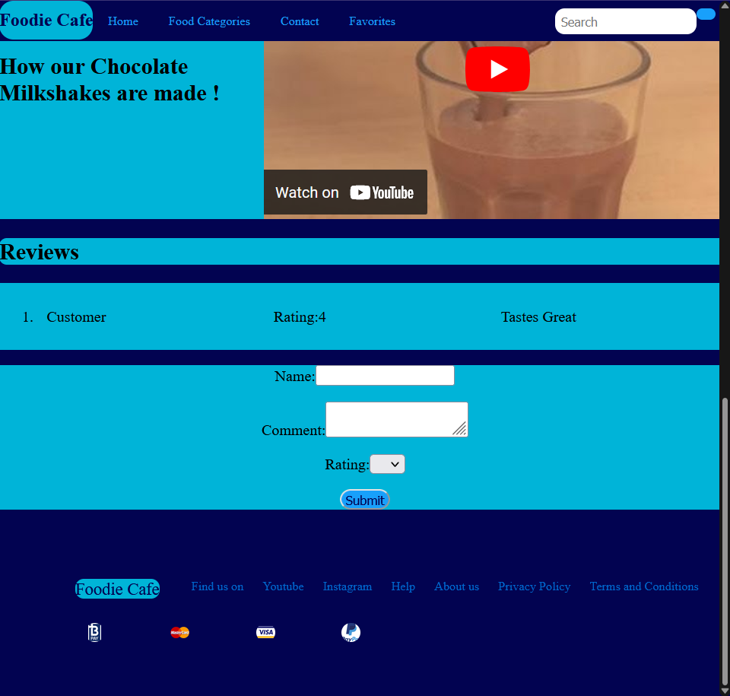

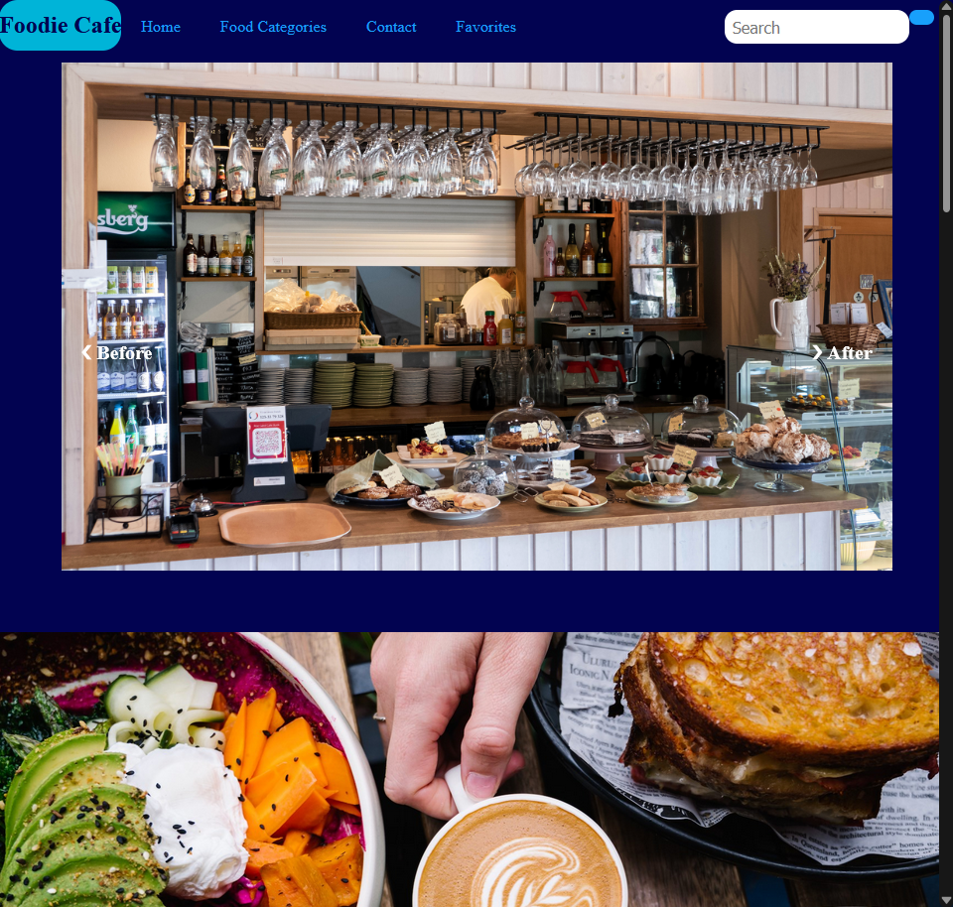

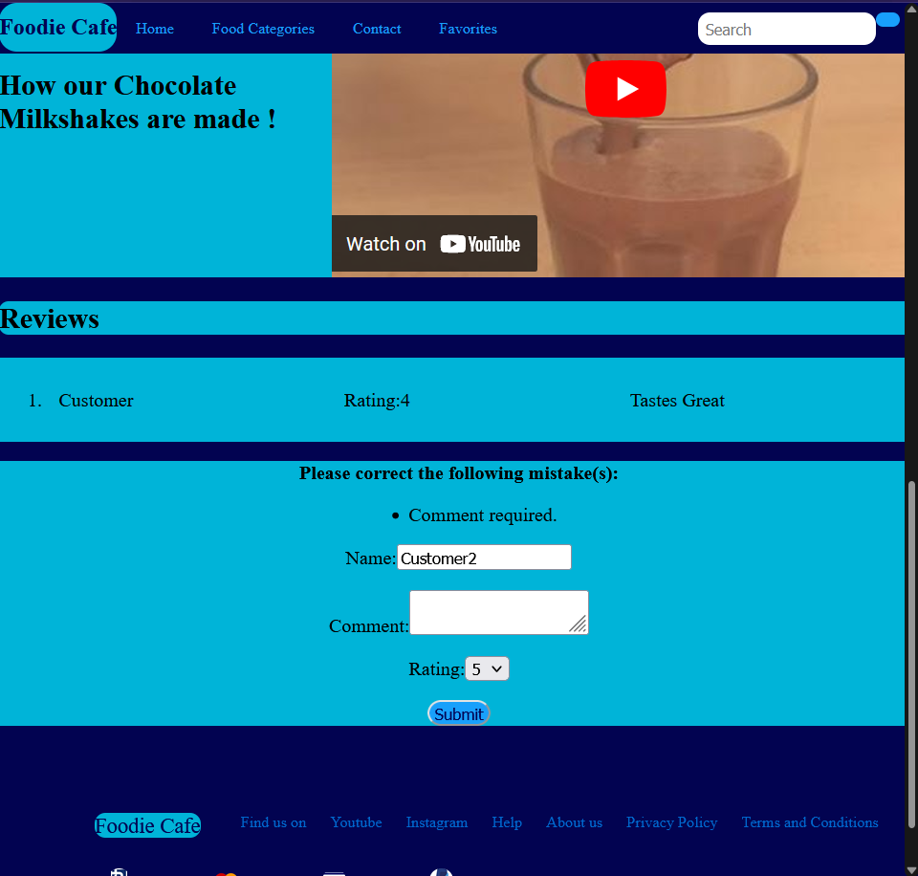

Week 07

I created a login page using v-model and input types to get email and password, these were placed in a form, where required was used on both fields so the submit button cannot be pressed if an input is missing. Then I looks in to routers in vue and how I can use them to direct from one page to another, then I started to use router and created paths from the login page to the home page then to the product page. I started to add a basket component to the product page but it is not working and I am still trying to figure out why, then for the basket I added a quantity amount for the product then decremented when the add to basket button is pressed, then added a v-if feature to disable the button when the quantity is equals to zero. The rest of the components and pages are working just fine.

